PROJECT DEVELOPMENT PHASE
MODEL PERFORMANCE TEST
Date | September 2026
Project Name | ServiceNow-Based Employee Laptop Request Application

Model Performance Testing
The project follows a ServiceNow-based employee laptop request workflow covering request submission, required details capture, approval routing, request-status tracking, asset availability checking, notifications and IT fulfillment. This is a workflow/request-management application rather than a machine-learning model; therefore, ML accuracy and tuning metrics are not applicable.
S.No. | Parameter | Values | Screenshot
1. | Model Summary | ServiceNow-based Employee Laptop Request Application.  Purpose: submit laptop requests, capture required details, route approvals, track request status, check asset availability, send notifications, and support IT fulfillment.  AI/ML model used: N/A. | 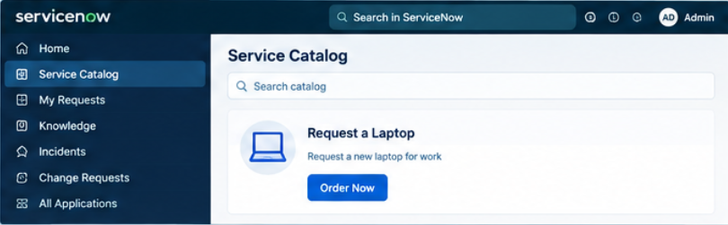
2. | Accuracy / Performance | Training Accuracy: N/A  Validation Accuracy: N/A  Reason: this is a workflow/request-management application, not a machine-learning model. | 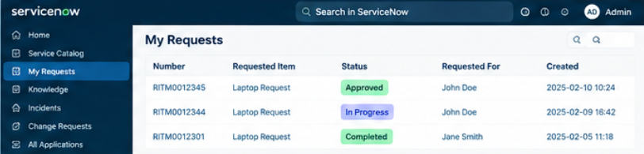
3. | Fine Tuning Result (if Done) | Hyperparameter Tuning: Not Applicable  Validation Method: Functional testing of request submission, approvals, status tracking, notifications and fulfillment.  Final validation result: To be updated after testing in the ServiceNow instance. | 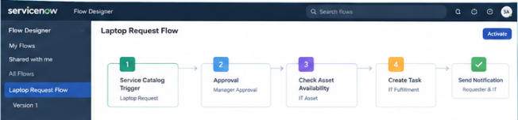

Note: This project manages employee laptop requests through ServiceNow. Model accuracy, validation accuracy, confusion matrix, MAE, MSE, RMSE, R² and hyperparameter-tuning metrics are not applicable unless an AI/ML model is added to the solution.

